**Date: 04-03-22**

**WEBLEM 5**

**Introduction to Visualization of Tertiary structure using RASMOL & PyMOL**

We can obtain all the available information about the 3D structure of this enzyme by browsing through the links or download the PDB file to a local directory in our computer and work with our preferred molecular modelling and visualization package.

**RasMol:**

RasMol is a computer program written for molecular graphics visualization intended and used primarily for the depiction and exploration of biological macromolecule structures, such as those found in the Protein Data Bank. It was originally developed by Roger Sayle in the early 90s. Historically, it was an important tool for molecular biologists since the extremely optimized program allowed the software to run on (then) modestly powerful personal computers. Before RasMol, visualization software ran on graphics workstations that, due to their expense, were less accessible to scholars. RasMol has become an important educational tool as well as continuing to be an important tool for research in structural biology.

**Installation:**

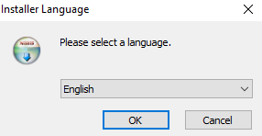

**Select language and proceed**

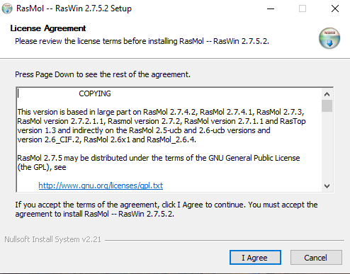

**Read the License Agreement and click “I Agree” to proceed**

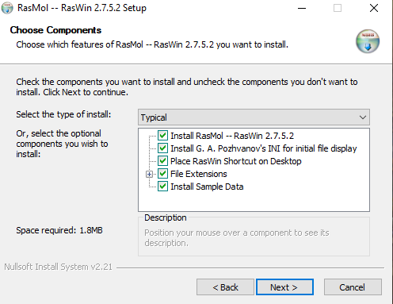

**Select the components of RasMol you want to install and click “Next” to proceed**

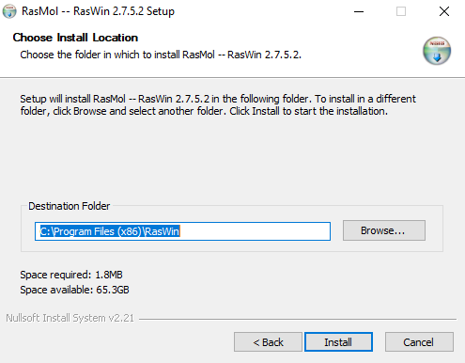

**Select the directory in which you want to install RasMol and click “Install” to proceed**

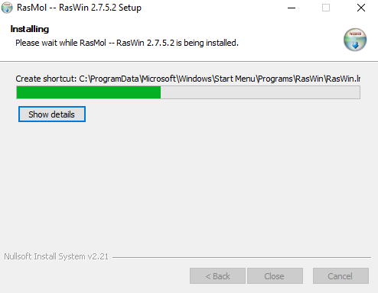

**The software will now install**

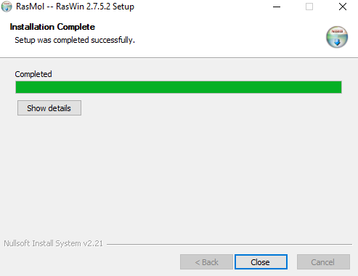

**Close the installer after the install is completed**

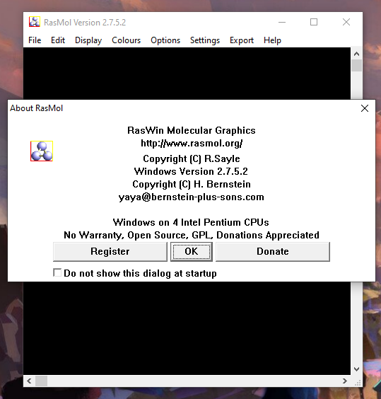

**RasMol is now installed**

**PyMol**

PyMOL, a cross-platform molecular graphics tool, has been widely used for three-dimensional (3D) visualization of proteins, nucleic acids, small molecules, electron densities, surfaces, and trajectories. It is also capable of editing molecules, ray tracing, and making movies. This Python-based software, alongside many Python plugin tools, has been developed to enhance its utilities and facilitate the drug design in PyMOL. To gain an insightful view of useful drug design tools and their functions in PyMOL, we present an extensive discussion on various molecular modeling modules in PyMOL, covering those for visualization and analysis enhancement, protein–ligand modeling, molecular simulations, and drug screening.

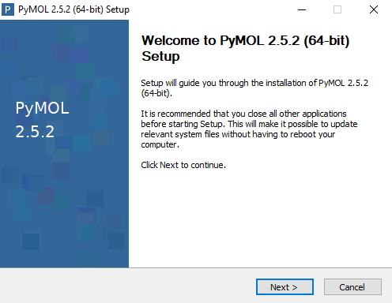

**Download and run the installer. Click next to proceed**

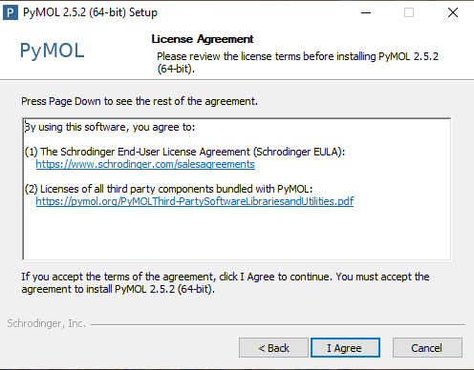

**Read the License Agreement and click “I Agree” to proceed**

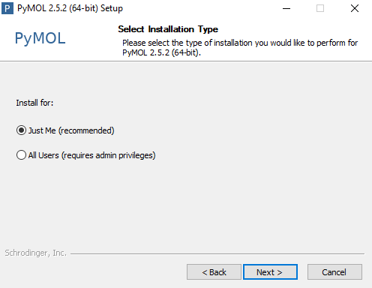

**Select the Installation type and click “Next” to proceed**

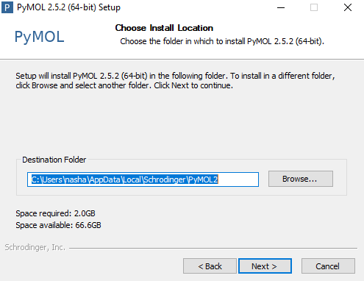

**Select the Directory in which you want to install PyMol**

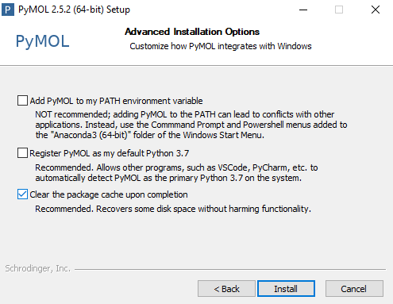

**Select the additional options if you want to and click “Install” to start the installation of PyMol**

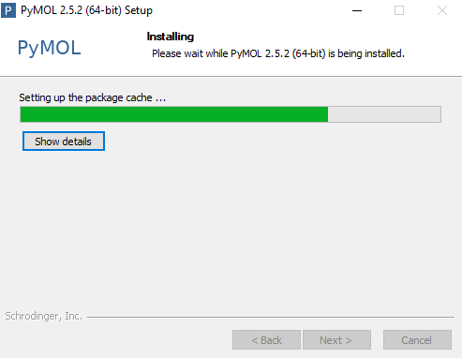

**Let the installer install PyMol**

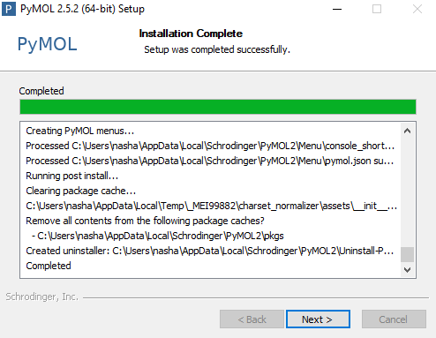

**After completion click on “Next” to finalize installation**

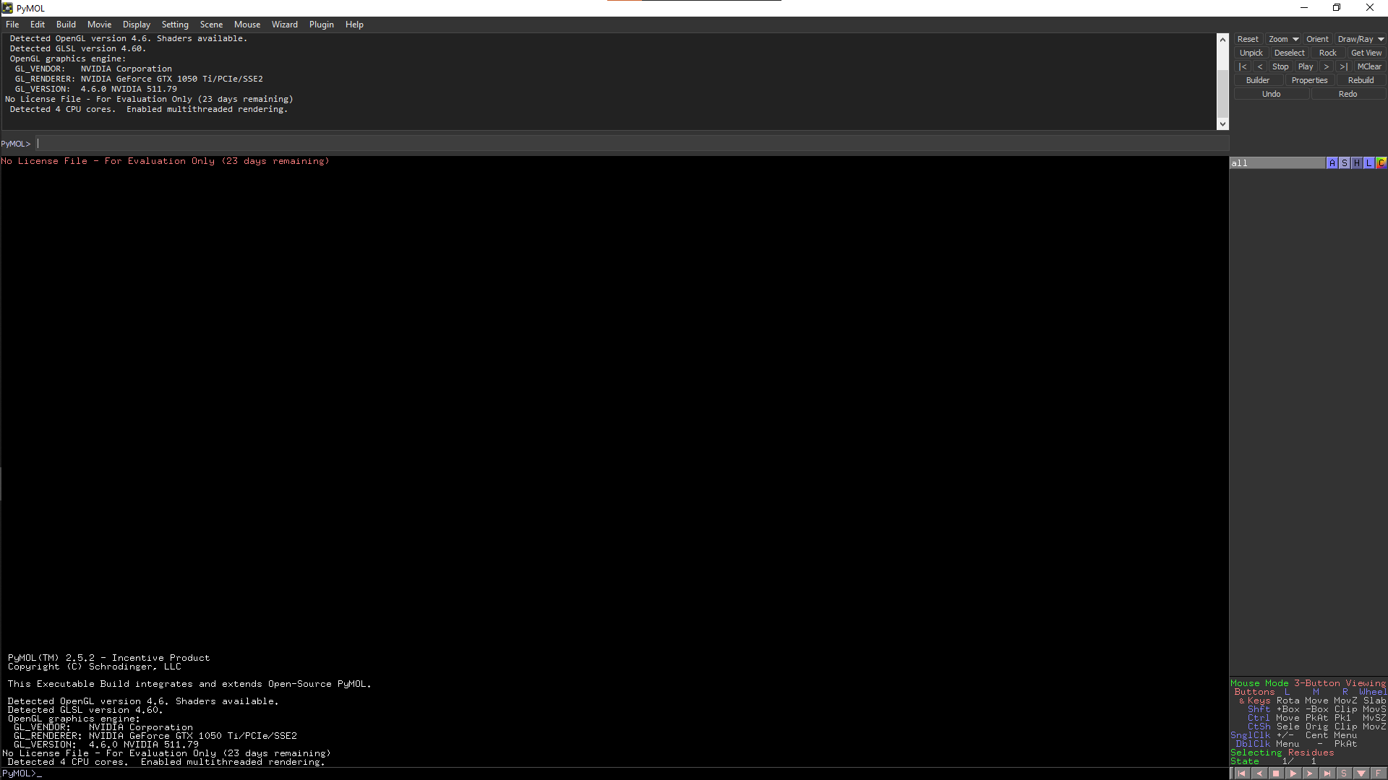

**Pymol is now installed**

**Date: 04-03-22**

**WEBLEM 6A**

**To visualize 3D structure of Hemoglobin (1SI4) using RASMOL & PyMOL tool**

**RASMOL:**

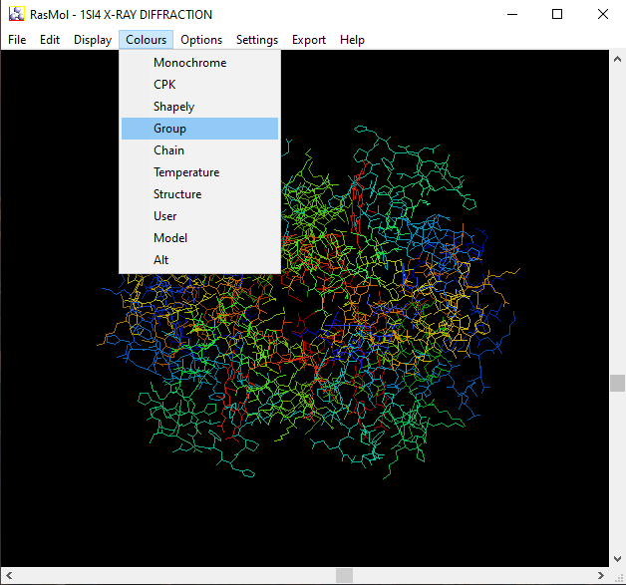

**Fig1. PDB Structure of Hemoglobin (1SI4) loaded in RasMol to show it in 3D space with the colour scheme set to Groups**

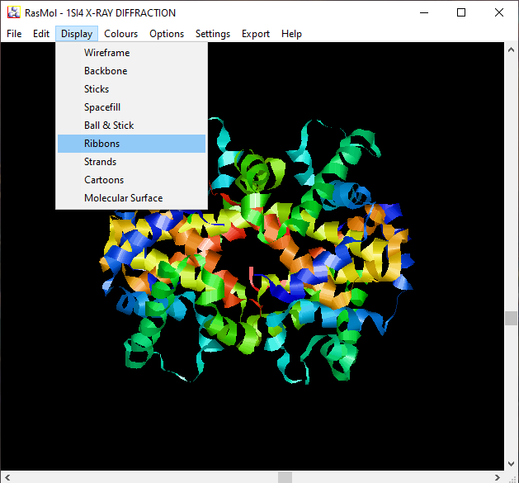

**Fig2. PDB structure of Hemoglobin (1SI4) Shown with the display mode set to ribbons**

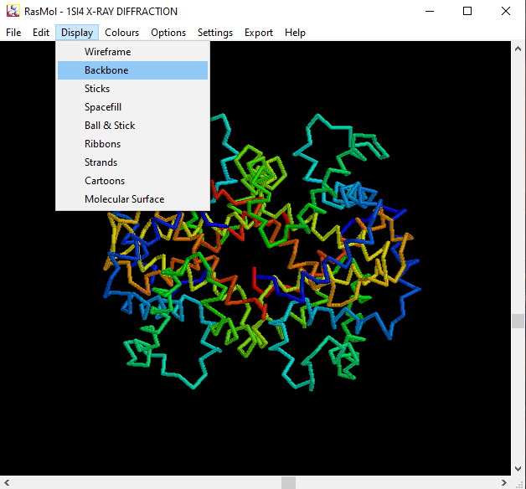

**Fig3. PDB structure of Hemoglobin (1SI4) shown with display type set to Backbone**

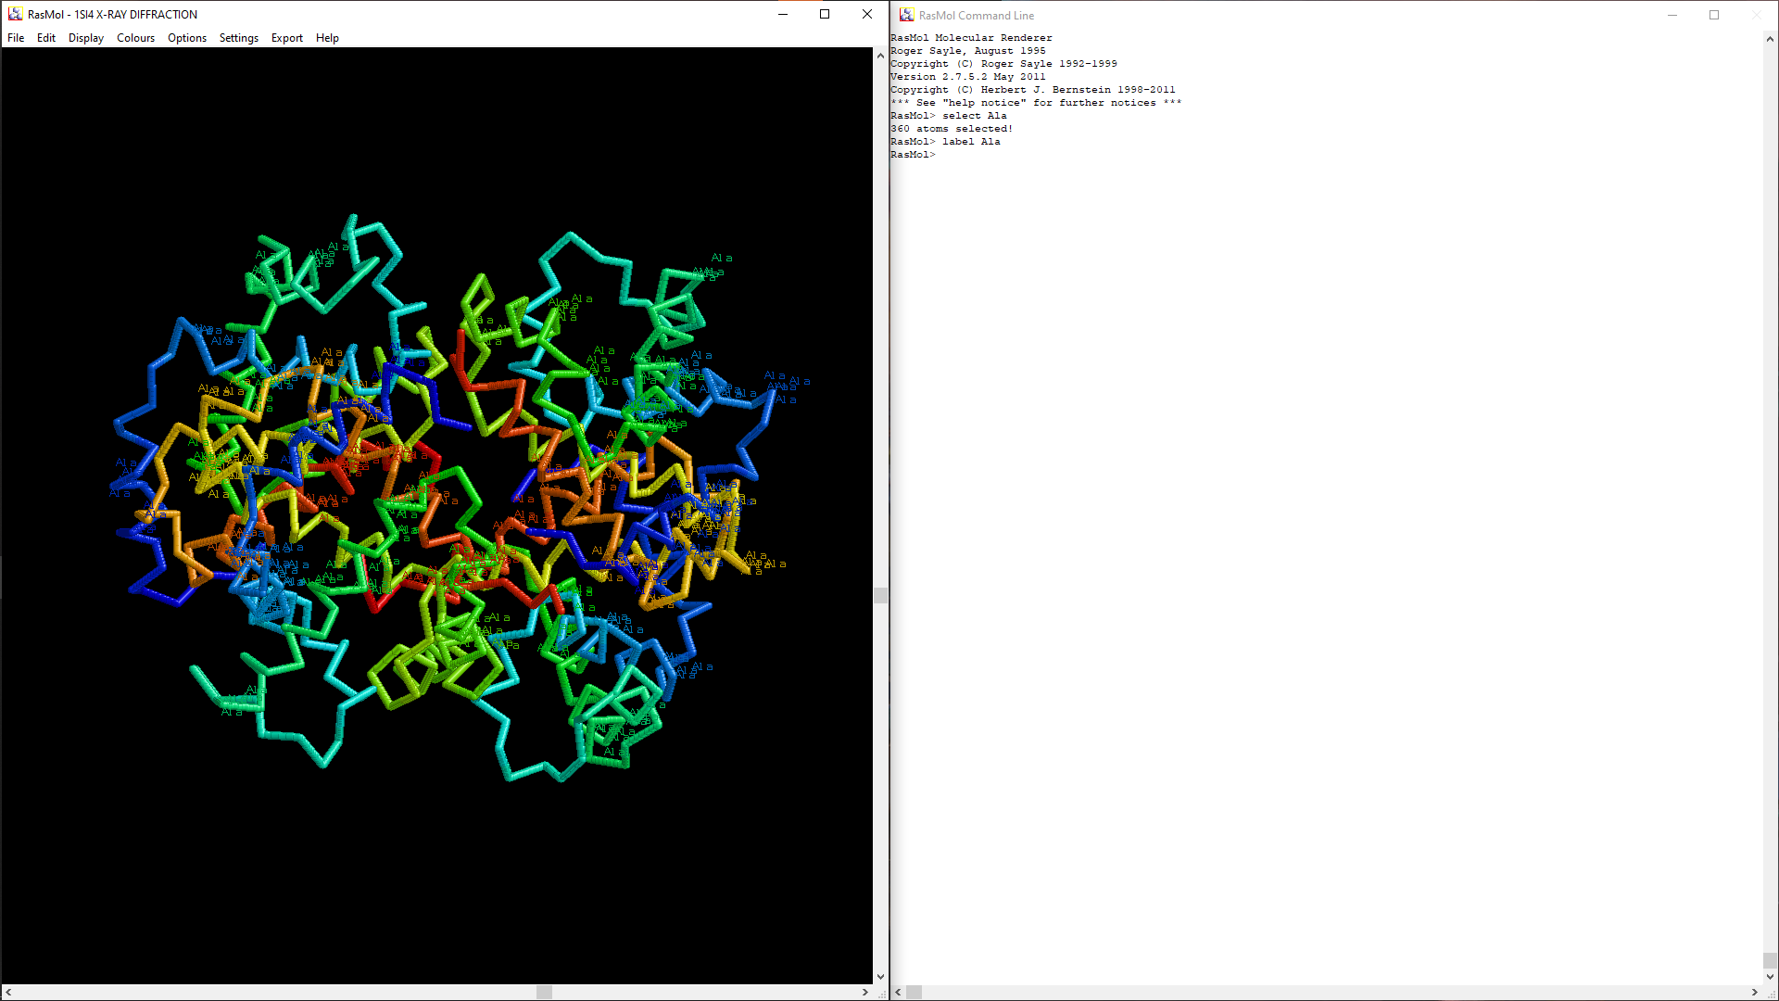**Fig.4 PDB Structure of Hemoglobin (1SI4) visualizing Alanine in the structure.**

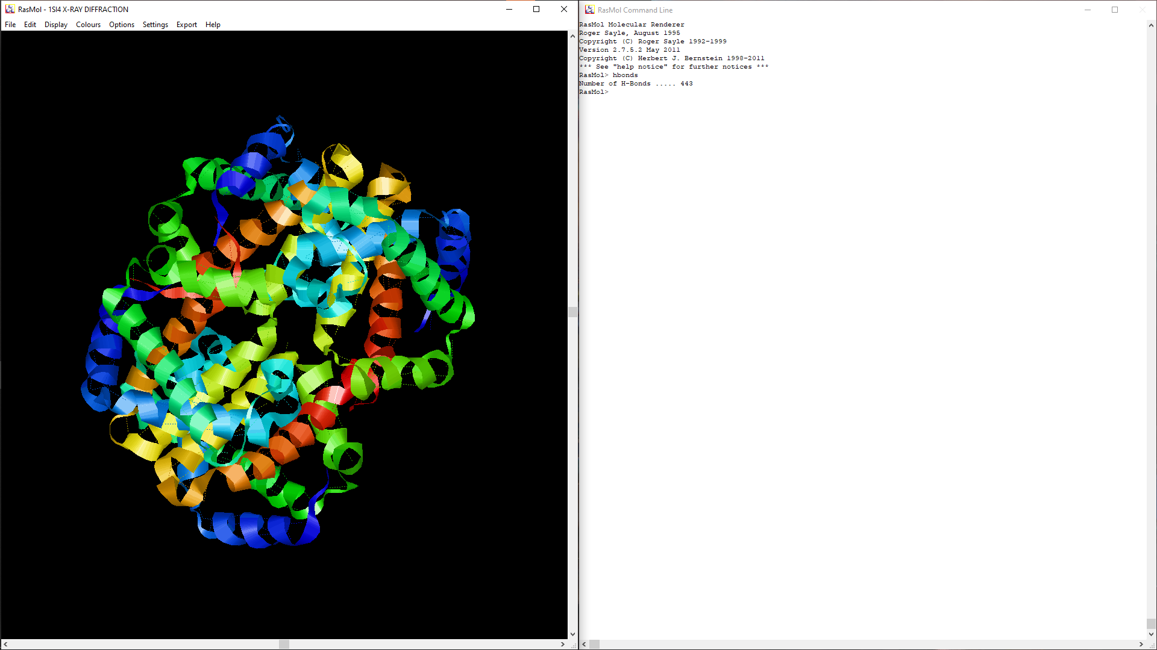**Fig5. PDB structure of Hemoglobin (1SI4) with Hydrogen Bonds visualized**

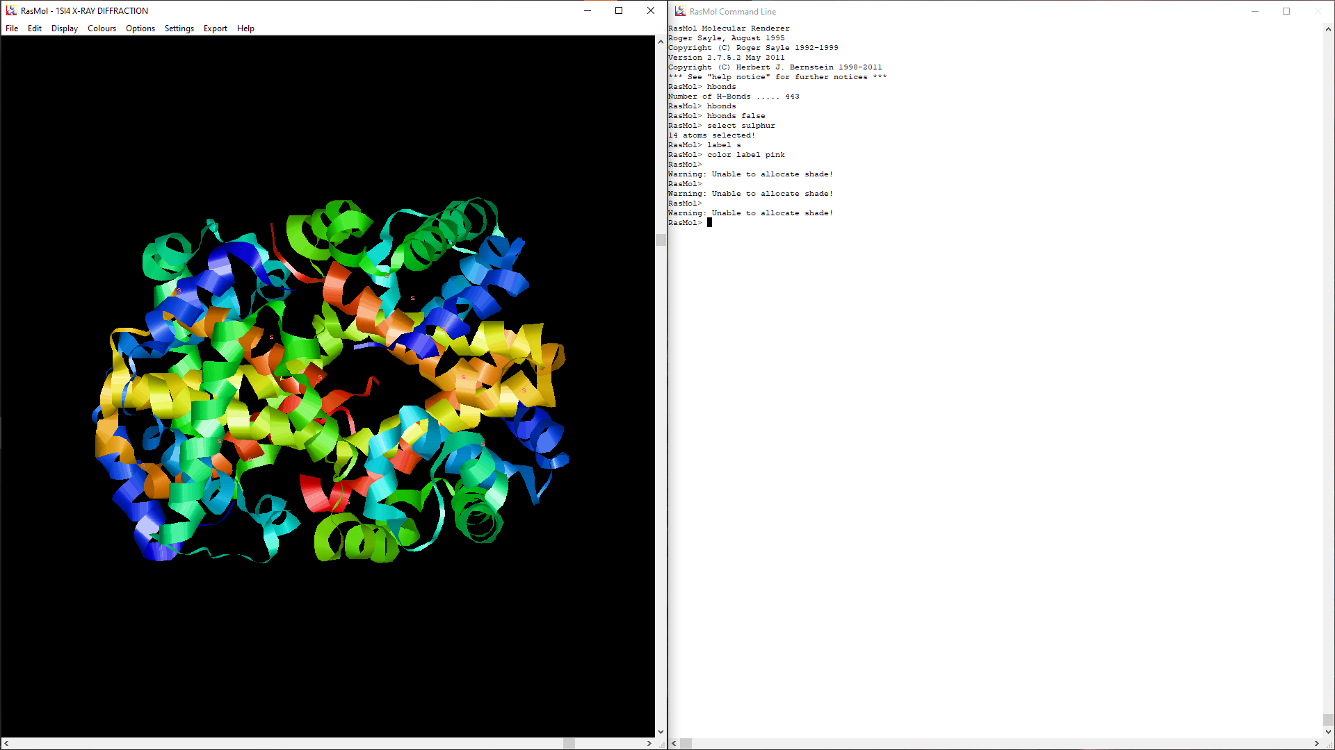**Fig6. PDB structure of Hemoglobin (1SI4) with sulphur atoms visualized with label “s”**

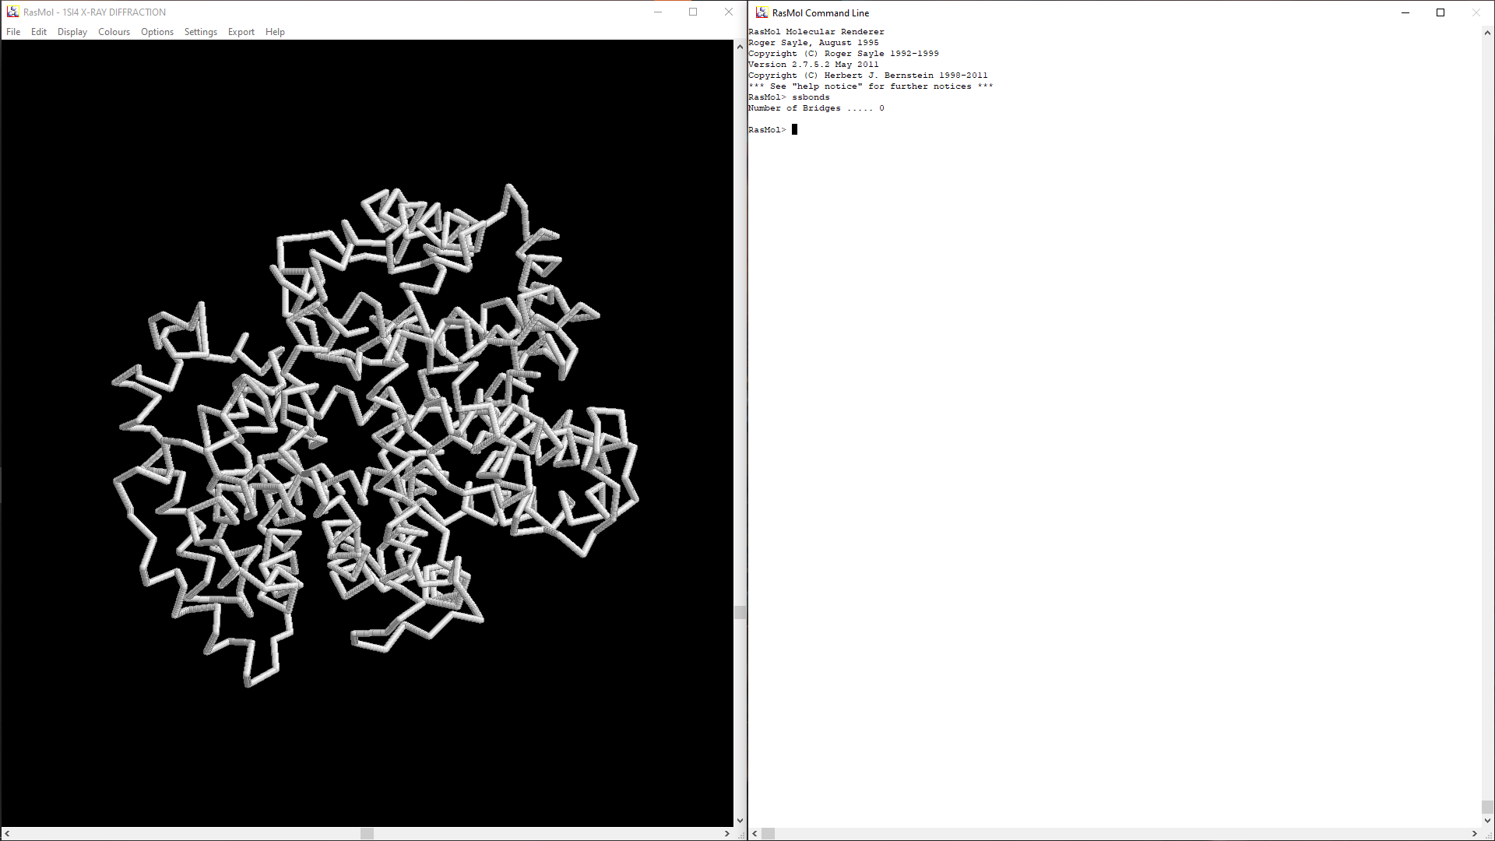**Fig7. PDB structure of Hemoglobin (1SI4) visualizing sulphuer-sulphur bonds (0 in this case)**

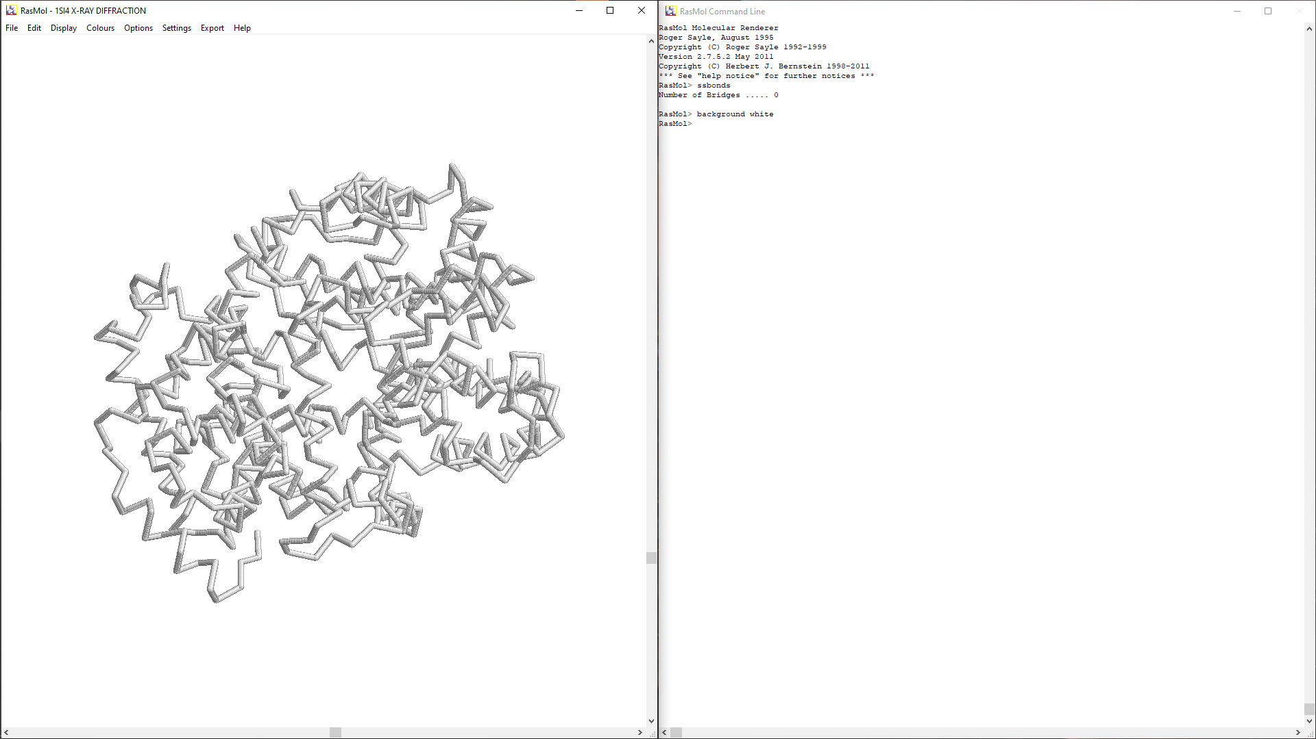**Fig8. PDB structure of Hemoglobin (1SI4) with the background color set to white to clearly see the sulphur-sulphur bonds (0 in this case)**

**PYMOL:**

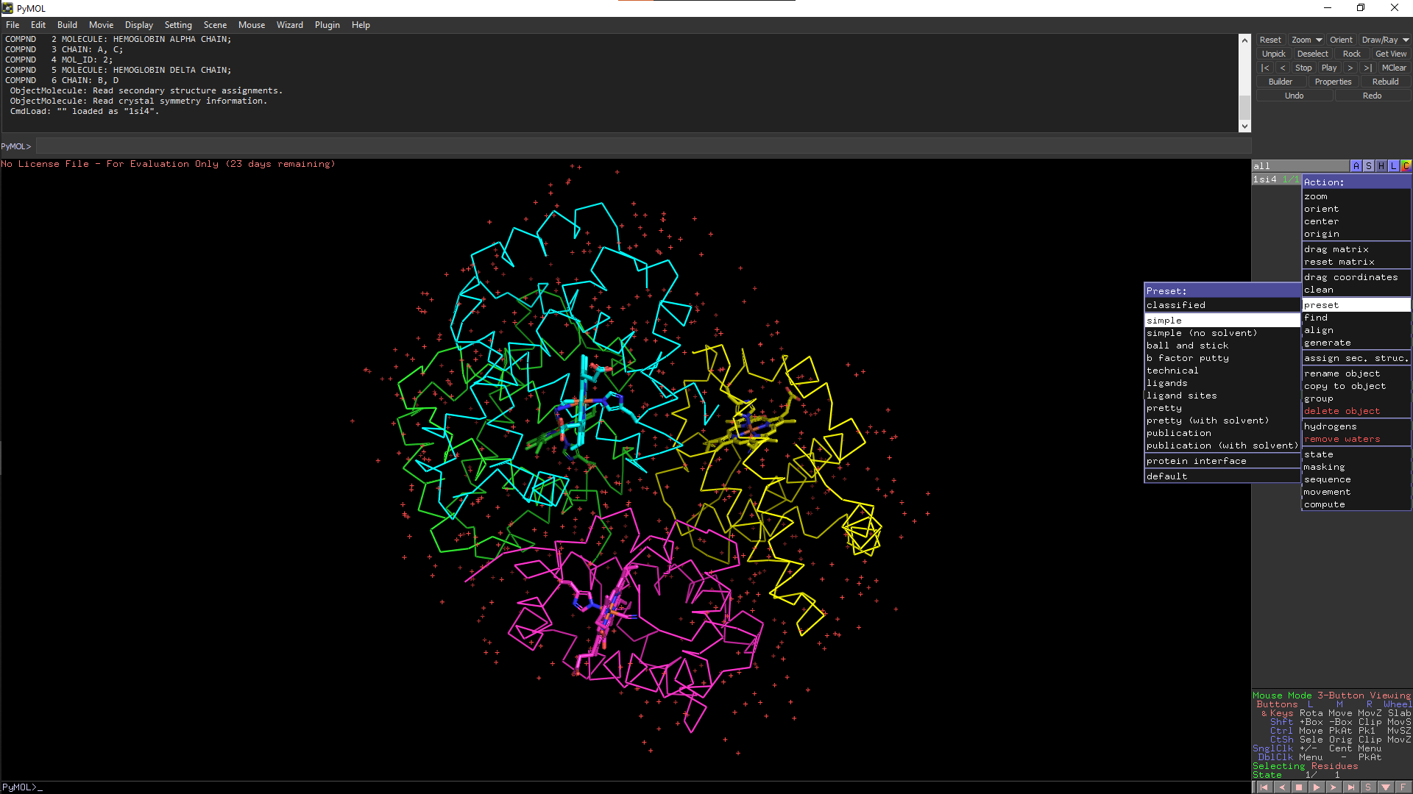

**Fig9. PDB structure Hemoglobin (1SI4) loaded in PyMol and set to simple view preset**

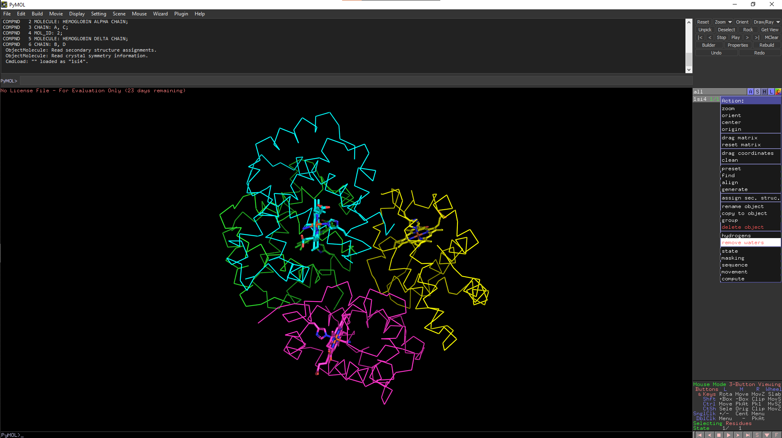**Fig10. PDB structure of Hemoglobin (1SI4) with waters removed**

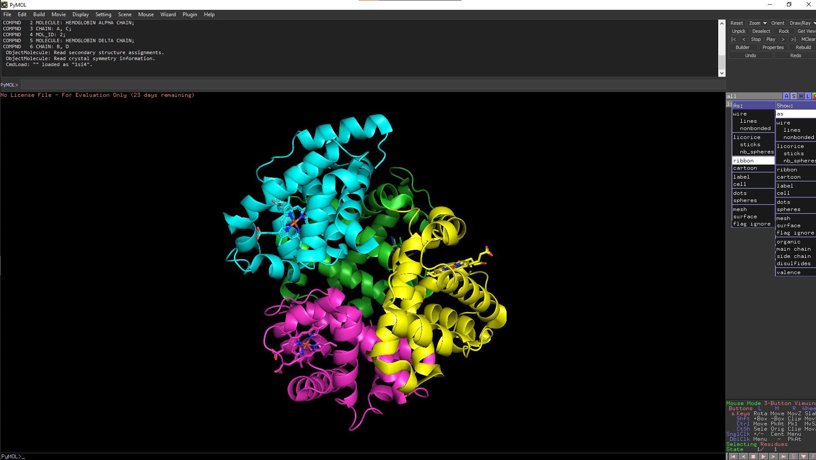**Fig11. PDB structure of Hemoglobin (1SI4) with visual style set to ribbon**

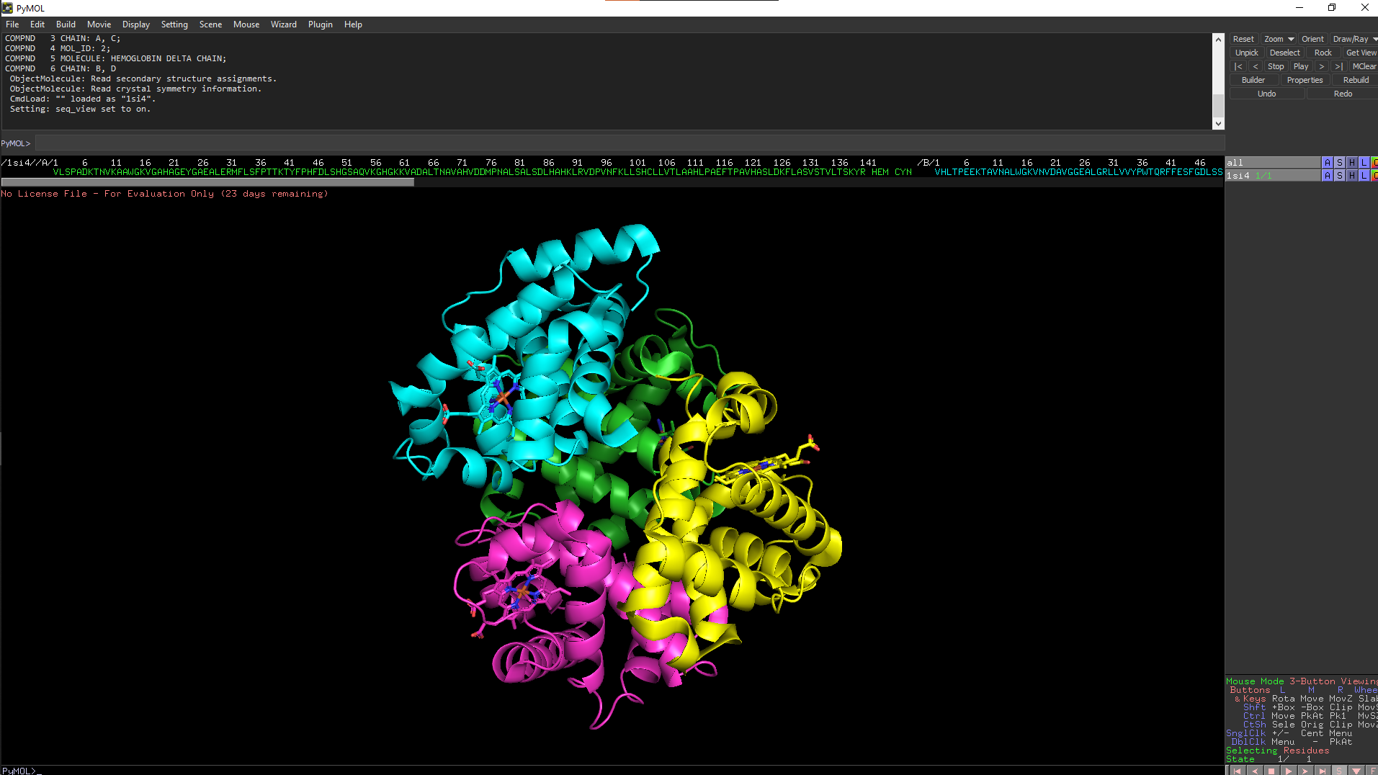**Fig12. PDB structure of Hemoglobin (1SI4) with the sequence displayed**

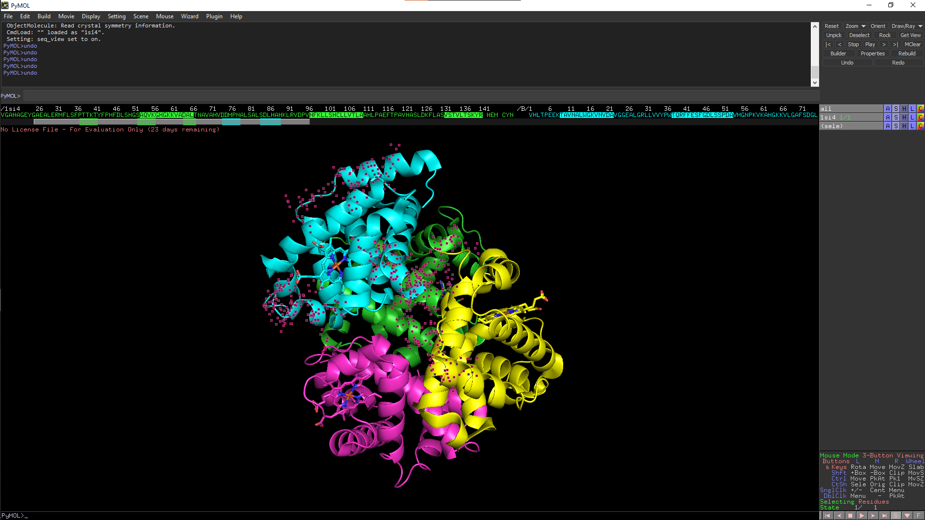**Fig13. PDB structure of Hemoglobin (1SI4) with random segments from sequence selected and visualized**

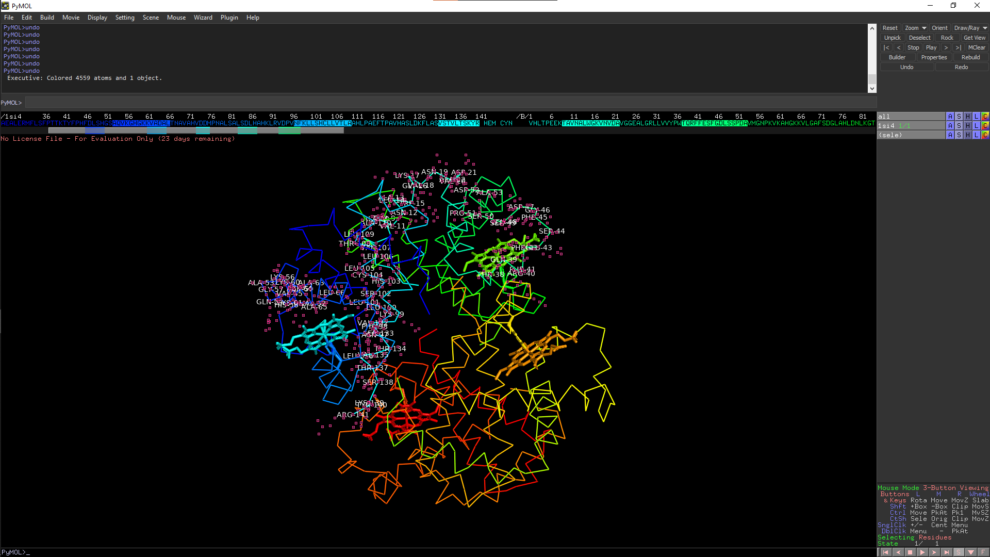**Fig14. PDB structure of Hemoglobin (1SI4) with the residues of the randomly selected segments from sequence visualized**

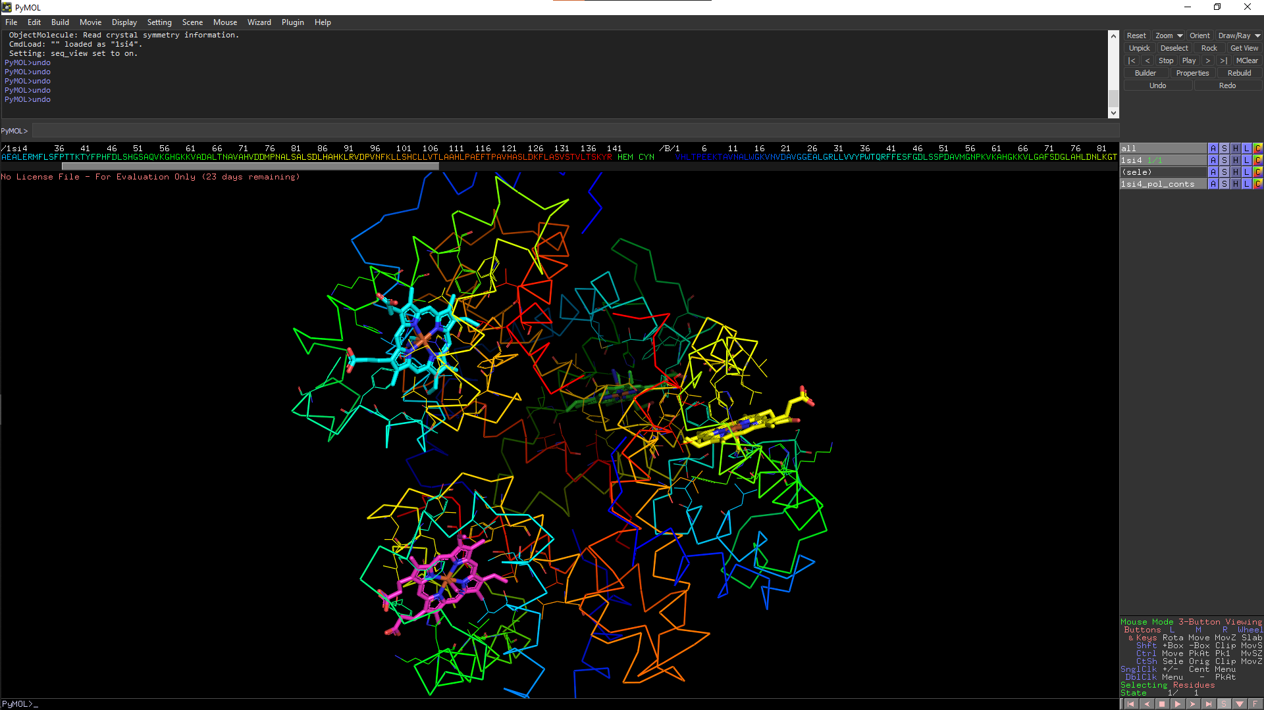**Fig15. PDB structure of Hemoglobin (1SI4) with it set to preset ligand view**

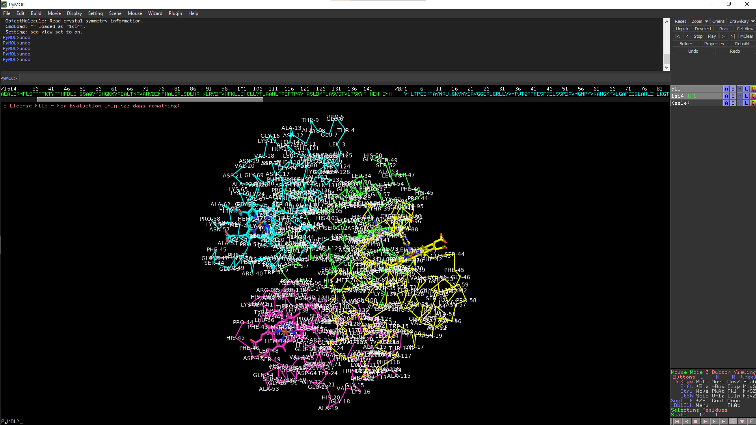**Fig16. PDB structure of Hemoglobin (1SI4) with all its residues labelled**

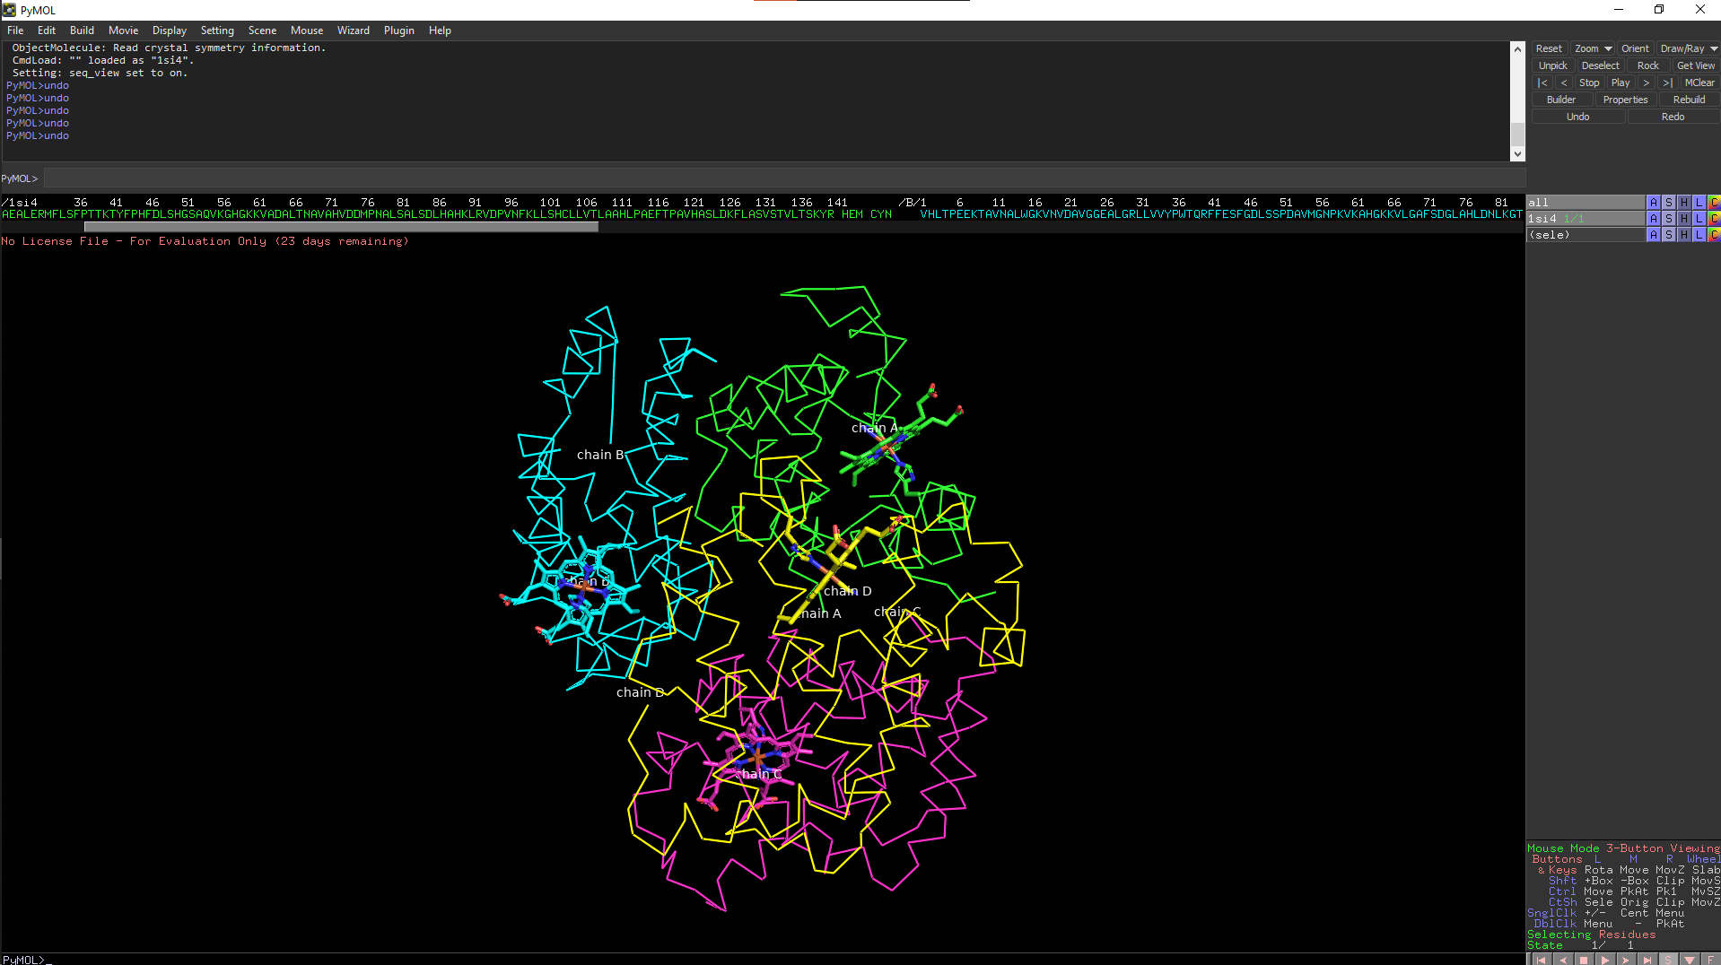**Fig17. PDB structure of Hemoglobin (1SI4) with all its chains labelled**

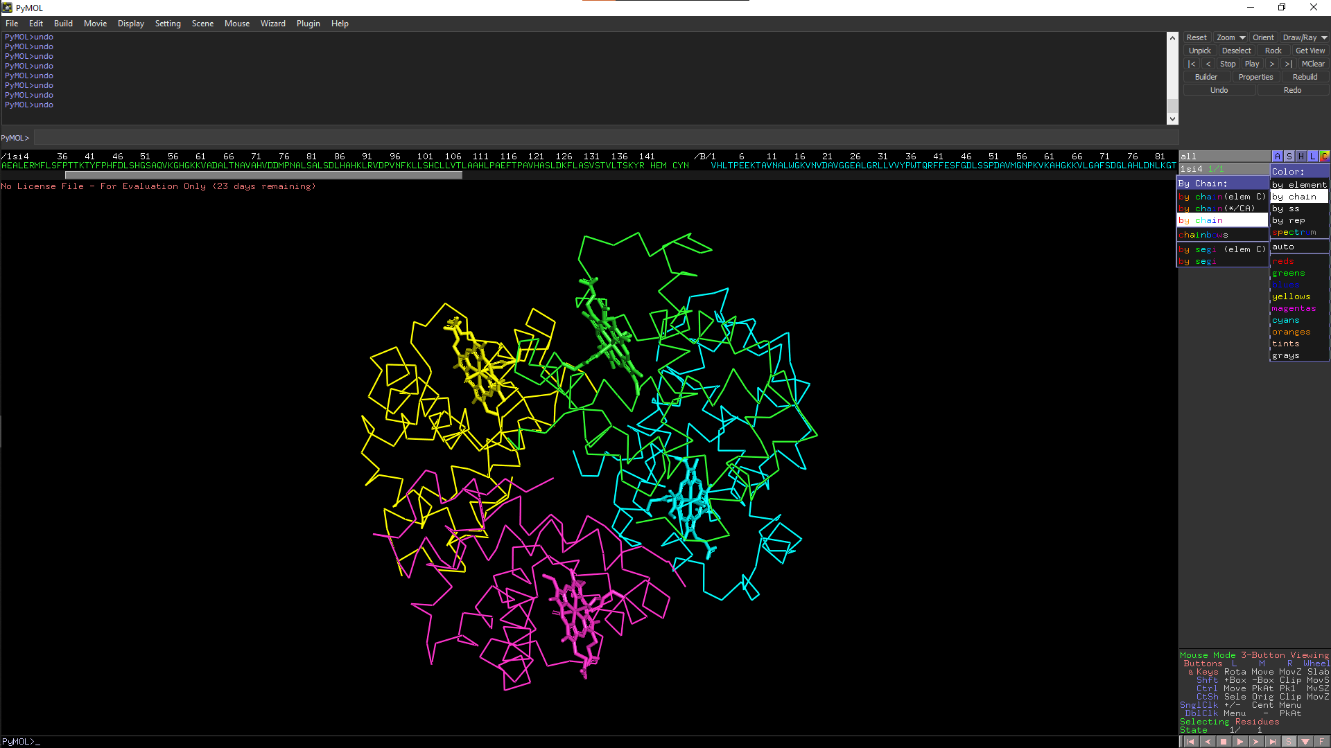**Fig18. PDB structure of Hemoglobin (1SI4) visualized with the chain color scheme set to rainbow**